

9B19M023

MOUNTAIN EQUIPMENT CO-OP: ENGAGING STAKEHOLDERS ON SOCIAL MEDIA

Ken Mark wrote this case under the supervision of Professor Michael Sider solely to provide material for class discussion. The authors do not intend to illustrate either effective or ineffective handling of a managerial situation. The authors may have disguised certain names and other identifying information to protect confidentiality.

This publication may not be transmitted, photocopied, digitized, or otherwise reproduced in any form or by any means without the permission of the copyright holder. Reproduction of this material is not covered under authorization by any reproduction rights organization. To order copies or request permission to reproduce materials, contact Ivey Publishing, Ivey Business School, Western University, London, Ontario, Canada, N6G 0N1; (t) 519.661.3208; (e) cases@ivey.ca; www.iveycases.com. Our goal is to publish materials of the highest quality; submit any errata to publishcases@ivey.ca. i1v2e5y5pubs

Copyright © 2019, Ivey Business School Foundation Version: 2019-04-12

In 2012, Mountain Equipment Co-op (MEC) based in Vancouver, British Columbia, embarked on a new strategic direction that would involve the first revamp of the company’s logo and brand positioning. In response to demographic and economic trends, MEC sought to broaden its reach to include urban consumers looking to participate in outdoor activities for the first time. The original logo featured the words “MOUNTAIN EQUIPMENT CO-OP®” to the left of a stylized image of a mountain. The new logo featured just the letters “MEC” in white, in the middle of a green square.

The logo change had been controversial. Anne Donohoe, chief marketing officer for MEC, chose to do a soft launch announcement in June 2013, followed by an official launch in September 2013. In anticipation of routine seasonal product rotations at the stores, an announcement revealing the new logo was sent out on June 18, 2013; the new MEC-branded merchandise was distributed in July 2013.

Donohoe had expected some reaction from MEC’s long-standing members following the reveal of the new logo, but not to the degree that was evident in the commentary on social media. A contingent of very loyal and vocal members were incensed. One activist, Marie Jensen, launched an online petition to gather 200,000 MEC member names to force a special general meeting. Her objective was to “[retain] the Mountain portion of the logo.”[1] Jensen, in the petition, cited commentary provided during the feedback process by “Todd N”:

The MEC logo has evolved over the years, appearing with either fully-lettered renderings of the name or with simply MEC alongside the mountains. However, the mountains have always been there.

We cling to our icons because of how they make us feel: The Nike swoosh, the Chevy bowtie, the Ford Oval, the Coca-Cola script, and countless others have survived their brand overhauls because they have enmeshed themselves in the public consciousness. So it is with the mountains.

The mountains mean something to the members. We identify with the brand and emblazon ourselves with the mountains as a source of pride and of potential for doing great things.

Faced with this backlash, MEC wanted to ensure that it was doing its best to address members’ concerns and communicate the co-operative’s side of the story.

In July 2013, as the newly branded merchandise was about to be distributed, Donohoe thought about the stakeholders involved and what her communications plan should look like:

We’re early into the new product launch and I’m wondering if we should actively respond to [the petition] and other posts. There are many issues to consider, and we need to know how we should respond to this and the other comments.[2]

Mountain Equipment Co-op

The founders of MEC had been buying climbing gear from U.S.-based Recreational Equipment Inc. (REI) in Seattle until they faced difficulties getting their purchases through customs in a timely manner. In 1970, after a snowstorm delayed them on one of their U.S. buying trips, the founders passed the time by working out a plan to start a co-operative that would sell rock climbing, mountaineering, ski mountaineering, and hiking gear in Vancouver, B.C.

As a co-operative, the new organization would sell products only to its members. A lifetime membership at MEC was set at CA$5[3]—a price that had not changed since the co-operative was founded in 1971. In the early days, members wanting to purchase product had to pay in advance and wait a few weeks for the product to arrive. MEC sourced its goods from REI and another Seattle-based company, Mountain Safety Research Inc., and applied a markup that was deliberately kept low, around 20 per cent.

Because MEC began without investment funding and with only $65 in operating capital contributed by its six founders, it was operated by a volunteer group from 1971 to 1974. The first few hundred members were drawn from the University of British Columbia’s students. The first catalogue was a single typed page, posted on a door at the university’s student union building. By accruing profits, the co-operative was able to open its first store in Vancouver, and in 1974, it began mailing catalogues to members. In 1976, MEC’s board of directors instituted a policy to distribute patronage dividends to members, proportionate to the purchases they made.

Over the next 25 years, MEC continued to grow by focusing on its core outdoor consumer: climbing, mountaineering, canoeing, and backwoods hiking enthusiasts. The annual catalogue mailed to members typically featured MEC members climbing, skiing, or camping in the wilderness. As its membership expanded, MEC began developing its own products, starting with a Gore-Tex parka in 1988.

The co-operative had an environmental and sustainability component in its focus—years before “corporate social responsibility” became popular. It purchased sensitive wilderness areas, used recycled materials in clothing, and constructed “green buildings” that featured energy-efficient designs and living roofs.

Even as it expanded to 17 stores and employed 1,728 people across Canada, MEC continued to be managed as a co-operative, returning several million dollars a year, on average, in patronage dividends to its members. In 2012, MEC carried more than 28,000 products at its 17 stores and reported sales of $302 million (see Exhibit 1).

Shifting Strategy

A shift in MEC’s strategy began in 2010, when company management noted that several long-term trends were emerging. More than two-thirds of MEC’s members lived in urban centres, and Canada’s population was becoming more racially diverse. These changes and others were reflected in MEC’s accountability report (see Exhibit 2).

Donohoe, who started in her position in 2013, led the co-operative’s efforts to remodel itself based on the shifting trends MEC had identified. She managed a team that was focused on developing a refreshed identity for the co-operative, including maintaining and upgrading the digital catalogue and creating online content such as user reviews and social media posts. She explained:

Starting around 2010, management saw that the rate of revenue growth was declining, that it was not as healthy as it should be. A review was conducted on the trends affecting the retail industry and our members. The Canadian population had changed—it was more urban and the way we recreate was different. We are participating in activities closer to home. Millennials are less likely to have drivers’ licences and just the way they are active has shifted. There was a realization that we needed to broaden our mission.

MEC’s purpose—helping members equip themselves for “self-propelled recreation in the wilderness”—was not in question; it would continue to be a cornerstone of MEC’s brand. But market research revealed that 80 per cent of Canadians lived in urban environments, meaning that they were more likely to spend hours set aside for recreation in urban settings such as indoor rock climbing or in spinning classes. Planning trips to wilderness settings would be far less likely to occur. The makeup of MEC’s membership was also changing, as Donohoe explained:

We started back in 1971 with university students. I believe we have always had a highly educated membership base. Our concern was actually around attracting and retaining female consumers (especially with the launch of brands like Lululemon) and attracting a more culturally diverse base. The issue was that the Canadian population was changing, our membership wasn’t, and we had lost the spark with many of our members. They weren’t sure what value they received as a member of MEC.

David Labistour, MEC’s chief executive officer, outlined the scenario MEC was facing in 2010:

We were still doing quite well at the time but, knowing that we were cresting the “Sigmoid curve,”[4] we decided to do a deep dive into the emerging trends and drivers. We looked way beyond just our business—at future demographics in Canada [see Exhibit 3], how approaches to recreation were changing, park usage, et cetera. We even looked at fertility rates and cultural change over the next ten years.

The signs did not look promising for us: we realized that we were very much playing in a traditional space that had been created by people who were aging and very Caucasian, in a world that was becoming younger and more culturally-diverse. It had also been a very masculine world. We needed to change our approach.

. . . We compete for the consumer’s discretionary time and money in the broader sport, leisure, and well-being market, and our market share within that segment is pretty small. We compete against the Sony PlayStation, Netflix, and Apple for the discretionary time and money of our consumer. Ten years ago, a young woman’s first discretionary expenditure was on footwear and clothing. Today it’s a phone and data plan. If we don’t look at these wider competitors, we will be lost, because we’re not just about “outdoor retail,” we’re in a much larger leisure arena.[5]

MEC’s leadership team realized that the co-operative’s original focus was to provide equipment and advice for a target group that was increasingly becoming a smaller part of its overall membership. “We got the go-ahead from the board to change the co-op’s purpose in 2011,” said Labistour.[6] MEC would look to add what Labistour called “hurdle activities.” He explained:

What I mean by hurdle activities is the easiest steps to get people into the outdoors, which would be walking, running, and cycling. We also brought in things like yoga, training, and fitness. We realized that because women were one of the biggest drivers of growth in our membership, we had to bring out lines of product that were appropriate and attractive to women.

We broke our product teams into three different groups: one that’s focused on backcountry technical product; one that is focused on active lifestyles and fitness; and another that is focused on the kind of lifestyle stuff that is after-activity and travel.[7]

“In shifting our strategy, we thought we also needed to look at our brand,” said Donohoe. She continued:

There was a general understanding that our brand was tired. People saw us as an iconic brand, but the spark was going out. There was not as much clarity about why one should become a member. We had a perception of catering to extreme, performance-oriented individuals, and this positioning was not as relatable to the average person. Our research showed that people weren’t aware what we offered. We had started, by 2011, to offer bicycles and more urban recreational goods, but perceptions had not caught up yet. We looked to how we could reposition our brand, to keep what was strong about it and not alienate our core audience, yet reach out to a broader population and be seen to be more relevant.

Until 2012, MEC’s three long-term goals focused on wilderness recreation and conservation. First, it aimed to increase participation in self-propelled, wilderness-oriented recreation in Canada, which was the co-operative’s core reason for its existence. Second, it would support the creation and stewardship of a comprehensive network of parks, wilderness, and outdoor recreation opportunities in Canada. Third, it wanted to foster change toward environmental, social, and economic sustainability in the marketplace. Having identified the changes, the co-op updated its charter in 2012 to reflect its purpose “to inspire and enable everyone to lead active outdoor lifestyles.”[8]

The logo redesign

Three years of research had been invested in developing MEC’s new broadened focus to include a more urban, younger target market. Consistent with that strategic change was an effort to update the co-operative’s image, and the logo change was part of this move.

In 2012, MEC tasked Roundpeg Inc., a research agency based in Minneapolis, to conduct focus groups and social anthropology research (i.e., social listening) for inputs into MEC’s rebrand strategy. In the focus groups, several key words stood out: *mountain biking*, *running*, *yoga*, *sea kayaking*, *snowboarding*, and *hiking*. In 2013, MEC commissioned Insights West to conduct a quantitative segmentation study and brand health study. Concrete Design (Concrete), a creative brand agency based in Toronto, was retained to design the logo and visual system, and to devise a new campaign slogan.

The agencies found that MEC was perceived as a destination store for people focused on outdoor activities such as mountain climbing, paddling, and rock climbing. However, urban consumers in general tended to prefer a range of local activities such as running, cycling, and yoga. “There was a risk that we could become disconnected with the largest segment of our membership,” noted Donohoe. “The data was telling us that we had to change our approach to retail strategy.”

The MEC team began working on a communications campaign, targeted to both internal and external stakeholders, to explain the evolution of MEC’s brand. Concrete developed a campaign concept to introduce the changes. The tagline “We are all outsiders” was an attempt to be more inclusive and encompass the range of activities enjoyed by the co-op’s members. Dianne Semark, design lead at MEC, noted the importance of sharing the rationale: “Internally, with staff across the country, we communicated the case for change—the vision for the future and why. It was then easier to rationalise the change in design as it linked back to the changes in business,” she said.[9]

The approach to the redesign of the logo started with the expectation that the existing, stylized mountain image would be retained, reworked at best (see Exhibit 4). Almost all of the sample redesigned logos presented to MEC included an image of the mountain. “Only one did not,” recalled Labistour. “We had never perceived a logo without a mountain on it.”[10]

The brand agencies conducted focus group research to understand how MEC’s consumers saw the co-operative. As the brand agencies worked through the iterations (see Exhibits 5–7), the idea of revamping MEC’s image became more appealing to the marketing team. The stylized mountain was eliminated, and the focus was placed on the three letters, MEC, placed against a green background. “Many people already referred to us as ‘MEC’ [*meck*],” Donohoe noted.

Labistour explained why a simpler logo—without the mountain—was eventually selected:

When we put all the final logos onto products, storefronts and new forms of communications—whether it be Twitter, Facebook, Instagram or our own app—it became evident that the more complicated the logo was, the less power it had. The simpler and more utilitarian your logo is, the more it shows up on the screen of a mobile phone.[11]

Donohoe added:

When we looked at the logos being suggested, we went in with our new positioning in mind. One of the other options we considered was the word “mountain” in type form. We ended up going with “MEC” and a green box. It represented a shift, a symbolic change, from the “mountain” heritage. We wanted to demonstrate that we can stretch across both “mountain” and “urban.” The rebrand reflects the reality of the new MEC. We’ve grown from six members to 3.5 million members over the last 40 years, many of whom live in urban centres. MEC has stayed true to its values yet is able to broaden its offering to more Canadians. Truly, our mission is to inspire Canadians to be active outdoors. Why do we go outdoors? To spend time with family and friends, to physically challenge ourselves, to explore.

The New Logo Is Revealed

On June 18, 2013, MEC’s new logo was revealed to the public for the first time as fall merchandise was made available in-store. Donohoe explained MEC’s plan for launching the new logo: “We chose to do the soft launch announcement in June, with an official launch in September. This followed a similar strategy that was successfully used by Starbucks: get the heat and passion out with the first launch and have a smooth rollout in the fall.”

Canada’s major newspapers carried news of the change, and members were interviewed about the rebrand.[12] Concrete’s campaign efforts to demonstrate that MEC was inclusive was captured in headlines: “No longer just for sandal-wearing granola eaters: Mountain Equipment Co-op trots out new logo in appeal to city folk,” announced the *Financial Post*.[13]

Reactions were posted on MEC’s Facebook page and on other social media sites (see Exhibit 8). While it was not always possible to tell from where the comments were originating, Donohue thought the majority of member comments critical of the new logo were originating from the West Coast, which was in line with expectations given that MEC had its roots, and thus its legacy, in the West.

MEC staff posted a response on its Facebook page:

Wow. What a huge response—we were expecting our members to take notice of the change, but it’s impressive to see your level of engagement.

We’re noticing a few common thoughts, and while we’d love to respond to each comment, we thought it would be helpful to write one comment from us to address a few topics.

So first off, the new logo. There’s another blog post coming tomorrow that describes the design process behind the new logo. We’re not saying this will make you love it, but we’re hoping the post will give some more insight into why the new logo was chosen.

A lot of you have commented on the direction of MEC. Yes, we’ve grown. We started with 6 members and now we have 3.9 million, including more than 250,000 new members last year. And with growth comes inevitable change. Through it all, MEC exists to help our members be active outdoors. Today, that means being active in the backcountry, in the city, or in the neighbourhood park you love (for many members, it’s all these spaces).

MEC’s a co-op. Differing opinions are part of any healthy co-operative. Your passion, comments, and engagement are proof of the thriving nature of MEC. Each comment is being read by our team, and we’re really impressed by your involvement.

Thanks,

MEC[14]

Donohoe and the MEC team were prepared for a lot more feedback and reaction to the revamped logo and MEC’s strategy in general. “The new logo has elicited a lot of feedback and we’re responding with frequent posts on Facebook,” said Donohoe. But Jensen’s online petition was also generating considerable response (see Exhibit 9). Donohoe wondered whether the co-operative should address the petition head-on or ignore it. If they chose to ignore it, Donohoe wanted to provide her management team with the reasons why; if they were going to respond to the petition, she needed to have a plan for doing that. The board of directors, too, wanted to know, among other things, what the marketing team had planned for social media stakeholder engagement.

Donohoe knew examples of firms that had backtracked on their rebranding efforts. In January 2001, Royal Mail Group Ltd.—the largest mail carrier in the United Kingdom—announced it would rebrand as “Consignia,” the culmination of a rebranding effort costing the carrier £1.5 million.[15] The effort was widely panned, with commentators such as Mike Verdin of BBC News calling the new name, “A duffer. A howling waste of money.” In 2002, the carrier spent another £1.0 million rebranding itself as Royal Mail.[16]

In October 2011, The Gap Inc., the clothing retail chain, revealed a new logo that Bill Chandler, Gap’s vice-president of corporate communications, called a “more contemporary, modern expression” of Gap’s brand. The public thought otherwise. In response to negative social media posts, user-led alternative logo contests,[17] and a parody of Gap’s brand on Twitter,[18] the company decided to solicit logo suggestions from readers.[19] Less than a week later, on October 11, 2010, Gap decided to revert to using its old logo.[20]

Just the week before MEC announced its own rebranding effort, Radio-Canada, the French language service of the Canadian Broadcasting Company (CBC) retreated on its decision to rebrand its organization.[21]

On the other hand, several companies had successfully redesigned their logos, including the National Football League, Dolby Laboratories Inc., Toys “R” Us Inc., MSNBC television network, and Bloomberg Businessweek. In each of these examples, the new logo was a slightly refreshed version of the original.[22]

Donohoe also considered the broader tactical issues the co-op faced. Assuming it was going ahead with the rebranding, MEC would need to deal with the opposition from long-term members who were satisfied with MEC’s previous identity and were committed to the old brand. She wondered, first, how MEC could proceed with the rebranding effort while continuing to engage and retain its core membership. What should MEC say to support this engagement and retention effort? Second, how should MEC communicate its message to its key stakeholders: who should deliver the message and what should the media mix look like? Third, Donohoe wondered whether the co-op should consider additional factors when developing its overall marketing communications plan for the next year.

Donohoe had a lot to consider and prepare for the upcoming meeting with the board of directors.

Exhibit 1: Mountain Equipment Co-Op’s Sales and Earnings before patronage bonus, 1999–2012

|  |  |  |  |  |  |  |  |
| --- | --- | --- | --- | --- | --- | --- | --- |
|  | **1999** | **2000** | **2001** | **2002** | **2003** | **2004** | **2005** |
| Sales (in CA$ ’000) | 139,670 | 144,882 | 153,963 | 162,709 | 169,605 | 178,387 | 195,829 |
| *% increase* |  | *3.7* | *6.3* | *5.7* | *4.2* | *5.2* | *9.8* |
| Earnings before patronage bonus | 8,014 | 7,061 | 1,845 | 2,432 | 6,244 | 13,003 | 11,528 |
| *% increase* |  | *−11.9* | *−73.9* | *31.8* | *156.7* | *108.2* | *−11.3* |
|  | **2006** | **2007** | **2008** | **2009** | **2010** | **2011** | **2012** |
| Sales (in CA$ ’000) | 222,812 | 239,069 | 247,730 | 262,056 | 261,374 | 270,157 | 302,040 |
| *% increase* |  | *7.3* | *3.6* | *5.8* | *−0.3* | *3.4* | *11.8* |
| Earnings before patronage bonus | 19,564 | 15,963 | 12,941 | 12,839 | 9,004 | 9,173 | 7,357 |
| *% increase* |  | *−18.4* | *−18.9* | *−0.8* | *−29.9* | *1.9* | *−19.8* |

Source: Company files.

Exhibit 2: Mountain Equipent Co-operative’s Goals and Strategy, 2010

Big Picture Trends

Economic forces, consumer behaviour, and societal trends all help shape MEC’s strategic priorities. Below are the top trends that influenced the Co-op in 2010, and that will affect our future direction. They create both opportunities and challenges.

1. **Demographics** – The face of Canada continues to change. Between 1956 and 2010, the median age of Canadians increased from 27 to 41, and the trend continues. Canadians are older, more ethnically diverse, and more urban. More young people are living at home. MEC embraces these changes by supporting lifestyles through relevant products and services for young adults and families, city dwellers and ethnic communities. And by embracing active outdoor lifestyles.
2. **New Media and Technology** – Technology is accelerating, from product development, to communications, to retailing. Mobile use is growing, communications are personal, online retailing is becoming the norm. We are continuing to invest in our website and new ways to engage with our members. As well, transparency expectations are higher, which means we’ll keep evolving accountability in our operations and supply chain (for example, by moving to online reporting).
3. **Leisure and Recreation** – Even though life is busier for many of us, people are not changing how much time they take for leisure and recreation. However, what’s changing is how this time is used. Backcountry trends are outpaced by more urban activities. Our members want to be outdoors, and there’s a growing interest in being fit and healthy. This means MEC will continue to serve our core, climbers and alpinists, while also offering gear for activities such as biking and running.
4. **Environmental Limits** – Ecological systems are declining, and natural resources—including water quality—are increasingly scarce. Costs for energy, water, and materials are increasing. The quality of places to recreate is changing. And climate change is affecting snow, seasons, weather patterns, and outdoor experiences. More regulations and standards are emerging, from carbon to consumer product safety to labelling. This inspires us to continue to reduce our environmental footprint, proactively invest in marketplace change and access conservation, and pursue supply chain traceability and improvement.
5. **Consumer Values** – Consumers make decisions based on trust, and expect transparency from businesses they engage with. Offering “eco” products is now a basic expectation, rather than a unique benefit. Few people will pay more for "responsible" products and services, they expect this in addition to quality and value. And sustainability means more than being “green.” People are interested in well-being, happiness, community, and purpose. This means we’re on the right track and will continue to embed social, environmental and economic priorities, and communicate our efforts as part of MEC’s bigger story as a retailer enabling outdoor active lifestyles.
6. **Global Economic Volatility** – The global economy is more volatile and ever-changing. China and India have emerged as big economic players, changing the role of North America. For us, this means less supply chain stability, changes in costs of goods, and socially responsible sourcing. So we will be even more proactive in how we communicate our expectations and manage our supply chain. Canadian Competition – The outdoor retail marketplace is constantly changing, and even more so in the past few years. There is more competition in Canada. MEC will continue to offer the best and most relevant products and services for quality and value-conscious members. It also means we’ll engage members in new ways.

Source: Extracted from Mountain Equipment Co-op, *MEC Accountability Report 2010*, 12–13, accessed February 8, 2019, www.mec.ca/media/Images/pdf/accountability/accountability-2010-report_v2_m56577569831149659.pdf.

Exhibit 3: Canada’s Demographics—Population by age and sex, 2011

|  |  |  |  |
| --- | --- | --- | --- |
|  | **Total** | **Male** | **Female** |
| Total - Age groups | 33,476,685 | 16,414,225 | 17,062,460 |
| 0 to 4 years | 1,877,095 | 961,150 | 915,945 |
| 5 to 9 years | 1,809,895 | 925,965 | 883,935 |
| 10 to 14 years | 1,920,355 | 983,995 | 936,360 |
| 15 to 19 years | 2,178,135 | 1,115,845 | 1,062,295 |
| 20 to 24 years | 2,187,450 | 1,108,775 | 1,078,670 |
| 25 to 29 years | 2,169,590 | 1,077,275 | 1,092,315 |
| 30 to 34 years | 2,162,905 | 1,058,810 | 1,104,095 |
| 35 to 39 years | 2,173,930 | 1,064,200 | 1,109,735 |
| 40 to 44 years | 2,324,875 | 1,141,720 | 1,183,155 |
| 45 to 49 years | 2,675,130 | 1,318,715 | 1,356,420 |
| 50 to 54 years | 2,658,965 | 1,309,030 | 1,349,940 |
| 55 to 59 years | 2,340,635 | 1,147,300 | 1,193,335 |
| 60 to 64 years | 2,052,670 | 1,002,690 | 1,049,985 |
| 65 to 69 years | 1,521,715 | 738,010 | 783,705 |
| 70 to 74 years | 1,153,065 | 543,435 | 609,630 |
| 75 to 79 years | 922,700 | 417,945 | 504,755 |
| 80 to 84 years | 702,070 | 291,085 | 410,985 |
| 85 years and over | 645,515 | 208,300 | 437,215 |
| Median age | 40.6 | 39.6 | 41.5 |

Note: Totals may not add up correctly due to rounding.

Source: Statistics Canada, Table 98-311-XCB2011006: Census Profile: Age and Sex for Canada (2011), accessed April 2, 2019, www12.statcan.gc.ca/census-recensement/2011/dp-pd/tbt-tt/Rp-eng.cfm?LANG=E&APATH=3&DETAIL=0&DI M=0&FL=A&FREE=0&GC=0&GID=0&GK=0&GRP=1&PID=103142&PRID=10&PTYPE=101955&S=0&SHOWALL=0&SUB=0&Temporal=2011&THEME=88&VID=0&VNAMEE=&VNAMEF=.

Exhibit 4: The Original mountain equipment co-op Logo

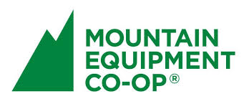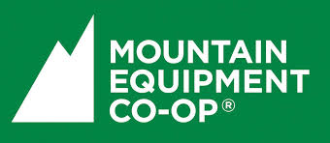

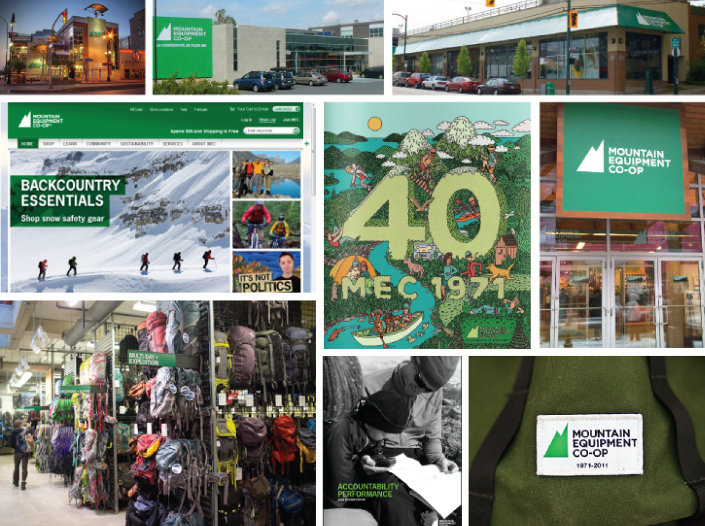

MEC’s Heritage

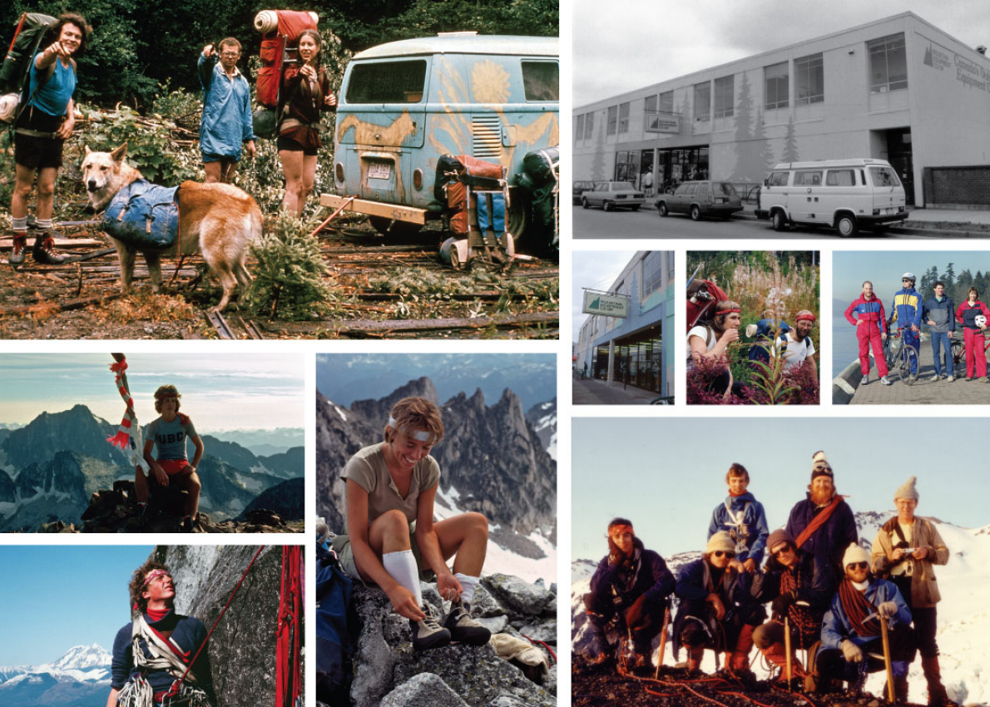

Source: Company documents.

Exhibit 5: The mountain equipment co-op Logo Redesign Process

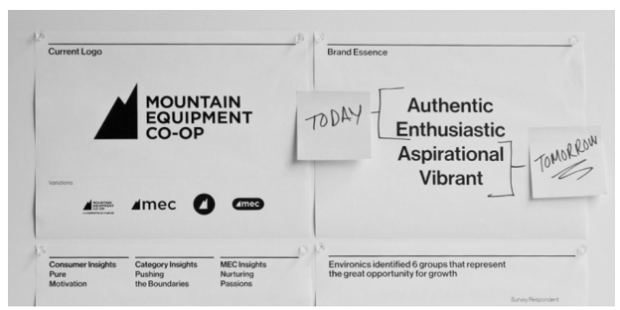

Source: Company documents.

Exhibit 6: mountain equipment co-op Logos that were considered

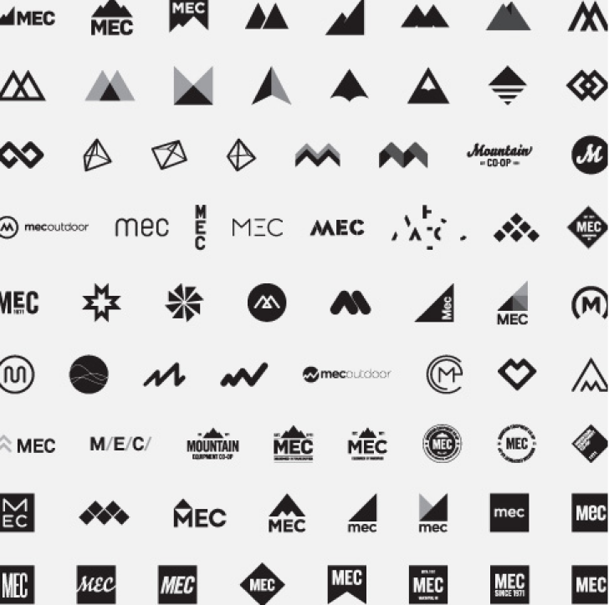

Source: Company documents.

Exhibit 7: The New mountain equipment co-op Logo and Positioning

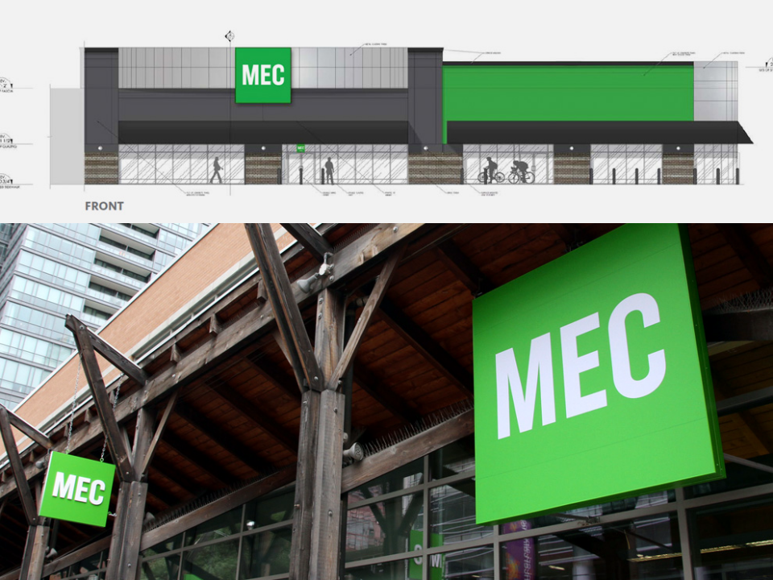

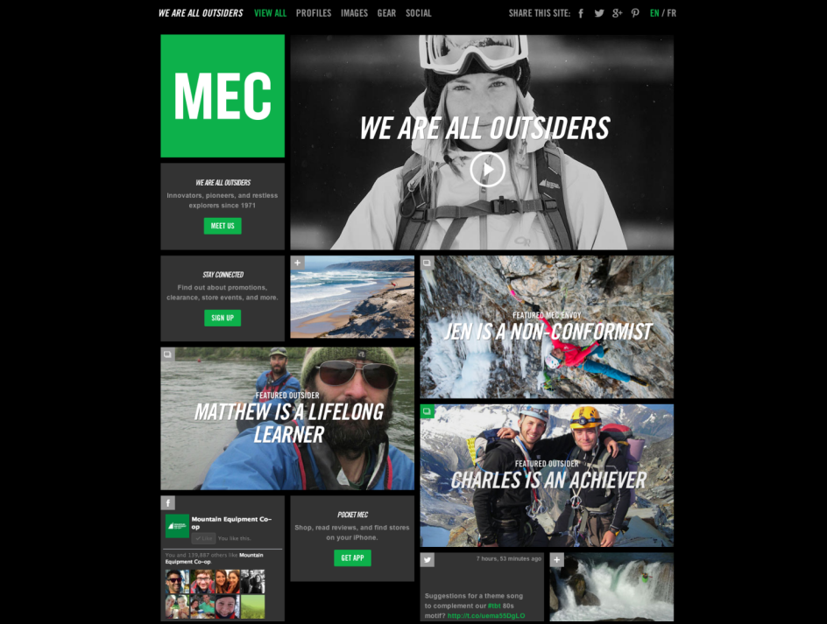

Exhibit 7 (continued)

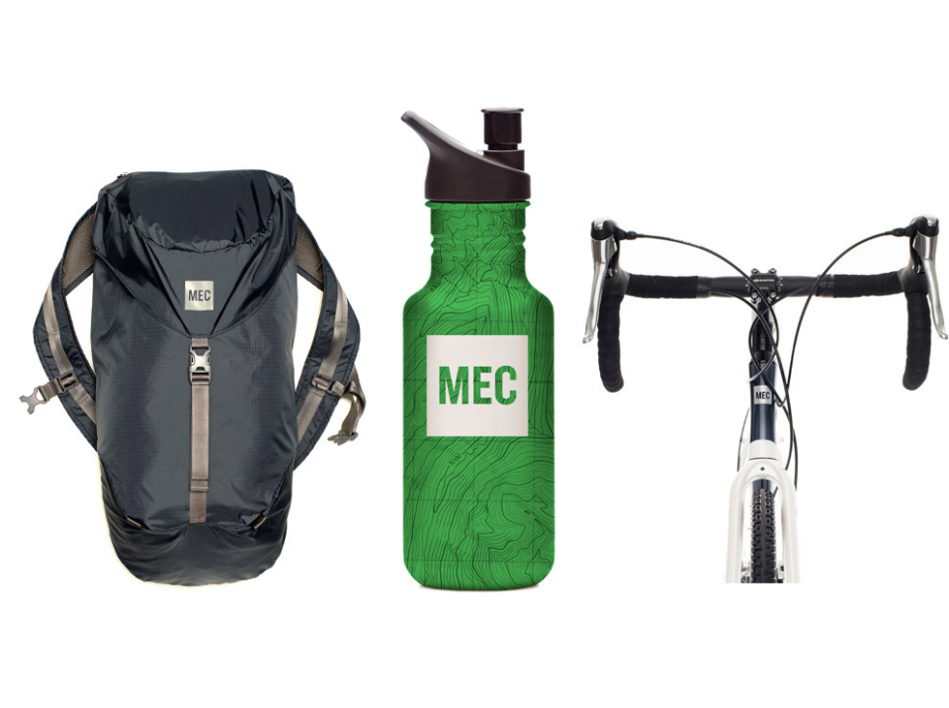

Source: Company documents.

Exhibit 8: Comments on Mountain Equipment Co-op’s logo on its Facebook Page

* You know what? I like the Mountain. It’s like the Tim Hortons sign or the Canadian Tire triangle. It’s Canadian. Your new logo looks like the Gap logo. It says nothing about anything. Keep the mountain. — Scott Davis
* Why not go a step farther and re-name it Urban Equipment Co-op. Ridiculous. — Chris Petrus
* Mountain equipment coop present their new logo and it’s ugly as hell. Looks like GAP or GM. — Tim @timlapse
* Change is not always good. The mountain logo has a huge cultural impact—it is the secret Canada flag we carry with us across the world. — Matthew Eglin

Source: “New MEC Logo Doesn’t Go over Well with Co-Op Members,” Storify, accessed February 3, 2016, https://storify.com/theprovince/new-mec-logo-doesn-t-go-over-well-with-co-op-members.

Exhibit 9: Comments on Mountain Equipment Co-op’s logo on Change.org

More in-depth criticisms were posted by members who were not pleased with the change. Many perceived that MEC’s rebranding campaign was a thinly-disguised effort to push growth over the co-operative’s values.

* While I do not completely understand the complexities of the competitive landscape that MEC faces, I do understand...
* the value of an iconic brand that has strong recognition and took 40 years to build
* that a shift to support a wider range of users does not necessarily require hiding your hard-core roots (in fact, pretension to that status is sometimes a bonus to the new users . . . see brands such as Northface, Arc’teryx, Canada Goose, etc.)
* a heavy-handed, secretive, corporate rebranding effort is disappointing behaviour in a co-operative organization
* there is an increasingly fine line between MEC and SportChek ... one that I seriously hope the co-op does not cross (if it hasn’t already)

My shopping experiences at the Vancouver store in the past few years have increasingly resembled shopping at any big box retailer with insufficient and untrained employees, and the rebranding to look more like a generic big box retailer makes me worry that this is not a coincidence, but perhaps fallout from a revised corporate strategy that, for some reason that has yet to be sufficiently articulated to me, does not appear to put members’ needs before expansion and profit (the focus on which is intriguing, as a co-op) — Debra Richardson, Vancouver, BC, Canada

* This desire to endlessly grow doesn’t suit the co-op. There is plenty of room to grow within the niche market that MEC was intended to supply. You can’t expect me to believe that diversifying your products towards more urban streams won't affect the availability and support for products that are true to mountain and other outdoor activities. There are only so many resources, staff, etc. at MEC and growth and breadth cannot come without compromise. . . . The new logo is terrible, but it also matches the direction that MEC is moving towards, which is what worries me the most. If the logo is reconsidered, great, but it’s still like killing the messenger of a bad message. Perhaps it’s time to re-evaluate the fundamental direction of the co-op. — Doris Leong, Vancouver, Canada
* The MEC mountain is an internationally recognized logo, identified as the Canadian outdoor coop company that could in the most obscure countries. The green lawn with MEC in the middle implies nothing but the traditional trend to cooperate greed-boring, expensive boring, now indistinguishable from Walmart. Sort of like Nike eliminating the swoosh (the MEC Mountain being extended peaking swoosh) because they want to sell lawn chairs. — Tekla Fulton, tekla@7sisterstrading.com, Canada
* Your new logo is a betrayal of 42 years of tradition, of the people who believed in the Co-op from the first days. While it is in the nature of business to evolve their brand, rarely is such a drastic step taken all at once. To remove the mountains from the nationally-iconic MEC logo renders the brand as sanitary and unwelcoming as an iPhone icon.

The MEC logo has evolved over the years, appearing with either fully-lettered renderings of the name or with simply MEC alongside the mountains. However, the mountains have always been there.

We cling to our icons because of how they make us feel: The Nike swoosh, the Chevy bowtie, the Ford Oval, the Coca-Cola script, and countless others have survived their brand overhauls because they have enmeshed themselves in the public consciousness. So it is with the mountains.

The mountains mean something to the members. We identify with the brand and emblazon ourselves with the mountains as a source of pride and of potential for doing great things.

EXHIBIT 9 (CONTINUED)

Lose them at your peril MEC. Without the mountains, the MEC logo becomes as bland and as culturally relevant as warm milk. — Todd N

* Logos have meaning and an MEC square has ZERO meaning. Mountains do not mean “granola” they are a symbol of the outdoors, the reason why most Mountain Equipment Co-Op members shop for gear there.—Kevin Baggott, SW Calgary, Canada
* As a member of 33 years the mountain logo has always resonated with the outdoors, with personal and group achievement, with toughness and innovation. For some companies, rebranding can be a refresh - but it can also be a misguided disaster that weakens the core identity. Please don’t do this.—David Elliott, Halifax, Canada
* I have been a member of the Co-op since the 80s. It has always had some problematic elements (it’s questionable attitude to women’s equipment) but it was always about the mountains and the backcountry. Who the f needs another GAP?—Leslie Howe, Saskatoon, Canada

Source: Marie Jensen, “Stop the Change of the Original Mountain Logo to the ‘Box’ Logo,” Change.org, accessed February 3, 2016, www.change.org/p/mountain-equipment-co-op-stop-the-change-of-the-original-mountain-logo-to-the-box-logo.

1. Marie Jensen, “Stop the Change of the Original Mountain Logo to the ‘Box’ Logo,” Change.org, accessed February 3, 2016, www.change.org/p/mountain-equipment-co-op-stop-the-change-of-the-original-mountain-logo-to-the-box-logo.
2. Except where indicated, all information based on personal communication with Anne Donohue (chief marketing officer, Mountain Equipment Co-op), April 28, 2017.
3. All dollar amounts are in CA$ unless otherwise stated.
4. Henry Cheang, “The Sigmoid Curve: A Model for Constant Business Growth and Innovation,” Cimpl, October 31, 2014, accessed September 7, 2018, https://blog.cimpl.com/the-sigmoid-curve-a-model-for-constant-business-growth-and-innovation; The Sigmoid curve was an S-shaped curve of activity across time; the top of the curve represented the peak of activity in growth.
5. Mark Leung, “Industry Insights: MEC CEO David Labistour,” RGD (Association of Registered Graphic Designers), June 27, 2015, accessed February 3, 2016, www.rgd.ca/2015/06/27/industry-insights-mec-ceo-david-labistour.php.
6. CB Staff, “How MEC Scaled the Heights to Become Canada’s Best Brand,” *Canadian Business*, October 15, 2015, accessed February 3, 2016, www.canadianbusiness.com/lists-and-rankings/best-brands/top-brand-2016-mec.
7. Ibid.
8. Mountain Equipment Co-op, *Annual Report 2013*, 9, accessed February 8, 2019, www.mec.ca/media/Images/pdf/2013_ME C_annual_report_v2_m56577569832393349.pdf.
9. Emily Andrews, “Spotlight on MEC,” Transform, November 20, 2015, accessed February 3, 2016, www.transformmagazine.net/articles/2015/spotlight-on-mec.
10. CB Staff, op. cit.
11. Ibid.
12. Morgan Campbell, “Mountain Equipment Co-op Changes Its Name to MEC,” *Star*, June 18, 2013, accessed February 3, 2016, www.thestar.com/business/2013/06/18/mountain_equipment_coop_changes_its_name_to_mec.html.
13. Canadian Press, “No Longer Just for Sandal-Wearing Granola Eaters: Mountain Equipment Co-Op Trots out New Logo in Appeal to City Folk,” *Financial Post*, June 18, 2013, accessed February 3, 2016, http://business.financialpost.com/news/retail-marketing/mec-logo-rebranding.
14. MEC, “Wow. What a Huge Response,” Facebook, June 18, 2013, accessed February 8, 2019, www.facebook.com/mec/posts/10151433095346610.
15. £ = GBP = United Kingdom pound; £1 = average of CA$2.229 in 2001 and CA$2.355 in 2002.
16. Tony Hardy, “10 Rebranding Failures and How Much They Cost,” Canny, October 14, 2013, accessed February 3, 2016, www.canny-creative.com/10-rebranding-failures-how-much-they-cost.
17. Alex, “Gap Redesign Contest,” ISO50 (blog), October 6, 2010, accessed February 3, 2016, http://blog.iso50.com/2010/10/06/gap-redesign-contest/#more-20224.
18. Gap Logo (@GapLogo), Twitter, accessed February 3, 2016, https://twitter.com/gaplogo.
19. Jennifer Van Grove, “Gap Asks Facebook Fans for Alternative Designs to Derided New Logo,” Mashable, October 7, 2010, accessed February 3, 2016, http://mashable.com/2010/10/07/gap-logo-redesign/#_sNnOLPLLqqB.
20. Ben Parr, “Gap Reverts to Original Logo after Social Media Backlash,” Mashable, October 11, 2010, accessed February 3, 2016, http://mashable.com/2010/10/11/gap-logo/#mF89.Z0Zimq4.
21. Canadian Press, “CBC Backtracks on Planned Radio-Canada Rebranding,” *Maclean’s*, June 10, 2013, accessed February 8, 2019, www.macleans.ca/general/cbc-backtracks-on-planned-radio-canada-rebranding.
22. “10 Successful Logo Redesigns,” Logo Design Love, September 15, 2008, accessed February 3, 2016, www.logodesignlove.com/10-successful-logo-redesigns.